

Project Interim Report

On

File Compression Simulator (Using Core Java & OOP Concepts)
RU-100-01-00012
Object Oriented Programming with Java

SESSION: 2025-26

Submitted By LEEJA SAHU
Reg No. RU-25-10749

Bachelor of Technology in Computer Science & Engineering with AI in Association with Google

Under the Guidance of
SOUMIK KARMAKAR

SCHOOL OF COMPUTER SCIENCE AND ENGINEERING RUNGTA INTERNATIONAL SKILLS UNIVERSITY
BHILAI, CG

(April 2026)

Abstract
The Music Playlist Management System is a Java-based application designed to manage and organize digital music playlists using object-oriented programming concepts. The project focuses on the use of aggregation, where a Playlist class contains multiple Song objects. Each song stores metadata such as title and artist, ensuring proper encapsulation of data.
This project is needed to simplify the process of managing music collections digitally instead of handling them manually. It allows users to add songs, shuffle the playlist, and display the list dynamically. The system demonstrates how real-world applications like music apps work at a basic level.
The application provides functionalities such as adding songs to a playlist, randomizing the order of songs using a shuffle feature, and displaying the playlist using enhanced loops. It effectively reduces manual effort and improves efficiency in managing songs. Overall, the project showcases the practical implementation of Java OOP concepts like classes, objects, encapsulation, and aggregation.

Introduction
The Music Playlist Management System is a simple Java application developed to manage digital songs efficiently. In this project, each song is represented as an object containing details like title and artist. A Playlist class is used to store multiple Song objects using an array, demonstrating aggregation.
This system allows users to add songs, shuffle their order, and display the playlist. It helps in understanding how music applications organize and manage songs internally. The use of encapsulation ensures data security by keeping variables private and accessing them through methods.
Objectives
- Manage song records
- Organize playlist efficiently
- Reduce manual work
- Apply OOP concepts like encapsulation and aggregation
- Provide shuffle functionality

Scope
This project is suitable for basic music management systems and can be used by beginners to understand Java OOP concepts. It can be extended in the future by integrating a database, adding a graphical user interface (GUI), and including advanced features like search, delete, and song categorization.

System Requirements
🔹 Hardware:
- Computer with minimum 4GB RAM
🔹 Software:
- Java JDK
- IDE (VS Code / Eclipse / Edit Plus)

Methodology
The working of the project follows these steps:
- First, the system initializes a playlist with a fixed size.
- The user adds songs by providing title and artist details.
- The songs are stored in an array inside the Playlist class.
- The user can view the playlist, which displays all songs using an enhanced for-loop.
- The shuffle function randomly rearranges the songs in the playlist.
- The updated playlist is displayed after shuffling.

Flowchart

Start
↓
Create Playlist
↓
Add Songs
↓
Display Playlist
↓
Shuffle Playlist
↓
Display Shuffled Playlist
↓
End
ClassName
🔹 Song Class
- Variables:
  - title
  - artist
- Methods:
  - Constructor
  - displaySong()

🔹 Playlist Class
- Variables:
  - Song[] songs
  - int count
- Methods:
  - addSong()
  - shufflePlaylist()
  - displayPlaylist()

Implementation
The project consists of two main classes: Song and Playlist.
- The Song class is used to store individual song details such as title and artist. It includes a constructor to initialize values and a method to display song details.
- The Playlist class manages multiple Song objects using an array. It includes methods to add songs to the playlist, shuffle the songs randomly, and display the playlist.
The main class creates a Playlist object, adds multiple songs, and performs operations like displaying and shuffling the playlist.

SAMPLE INPUT / OUTPUT
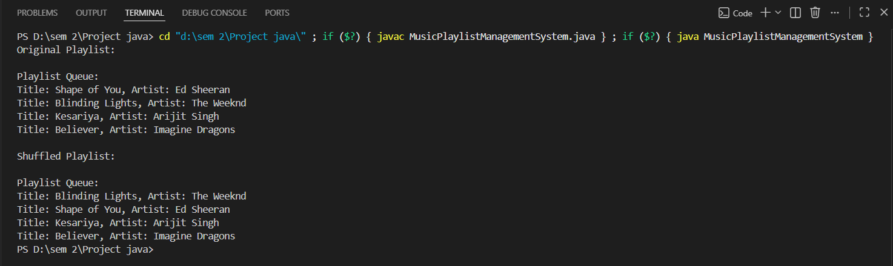

FUTURE ENHANCEMENTS
- Add GUI using Java Swing
- Integrate database (MySQL)
- Add search and delete song feature
- Support for audio playback
- Create user login system

Gantt Chart
1. Planning & Structure
The project is divided into phases such as designing classes, coding, testing, and documentation.
2. Time Management
Each task is assigned a timeline:
- Design → Day 1
- Coding → Day 2–3
- Testing → Day 4
- Documentation → Day 5
This helps in completing the project efficiently without delays.

Conclusion

The Music Playlist Management System successfully demonstrates the implementation of Java OOP concepts such as classes, objects, encapsulation, and aggregation. It provides a functional system for managing songs and playlists efficiently. The project also serves as a strong foundation for developing more advanced applications in the future.

References

Book

[1] Java: The Complete Reference, 11th ed. New York: McGraw-Hill, 2018.

[2] Head First Java, 2nd ed. Sebastopol: O'Reilly Media, 2005.

Website

[3] Format: Java Documentation, "Java Documentation," Oracle. [Online]. Available: https://docs.oracle.com

[4] Example: GeeksforGeeks, "Java OOP Concepts," GeeksforGeeks. [Online]. Available: https://www.geeksforgeeks.org

Conference Paper
[5] Format: S. Kumar, "Object-Oriented Programming in Software Development," in Proc. International Conf. on Computer Science, 2021, pp. 101-105.

Journal Article
[6] Format: A. Sharma and R. Gupta, "Application of Object-Oriented Programming in Java," International Journal of Computer Science, vol. 5, no. 2, pp. 45-50, 2020.

